**Objective Questions**

1. **Are there any tables with duplicate or missing null values? If so, how would you handle them?**

* **Finding Overview:** No missing, null or duplicate values were detected in any of the tables within the **ig_clone** database.
* **If such issues were found, the approach would be:**
* **Remove rows with missing or null values** when they do not add analytical value or break data integrity.
* **Use COALESCE() to replace NULL values with 0** (or another appropriate default) to maintain consistency during calculations and avoid errors in queries.

1. **What is the distribution of user activity levels (e.g., number of posts, likes, comments) across the user base?**

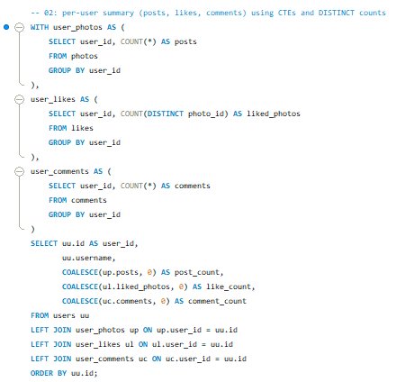

**RESULT–**

|  |  |  |  |  |
| --- | --- | --- | --- | --- |
| **user_id** | **username** | **post_count** | **like_count** | **comment_count** |
| **1** | **Kenton_Kirlin** | **5** | **0** | **0** |
| **2** | **Andre_Purdy85** | **4** | **94** | **66** |
| **3** | **Harley_Lind18** | **4** | **79** | **67** |
| **4** | **Arely_Bogan63** | **3** | **93** | **64** |
| **5** | **Aniya_Hackett** | **0** | **257** | **257** |

1. **Calculate the average number of tags per post (photo_tags and photos tables).**

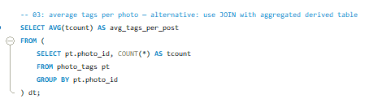

### **Explanation**

* **Subquery:**Calculates how many tags are associated with each post by counting tag_id in the photo_tags table.
* **Main Query:**Computes the average of these tag counts, giving the overall average number of tags used per post.

### **Suggestion**

* **Add User-Level Grouping:**

Grouping the results by user would provide deeper insights into which users consistently use more tags.  
This helps identify users who optimize tags effectively to boost post visibility and engagement.

**4. Identify the top users with the highest engagement rates (likes, comments) on their posts and rank them.**

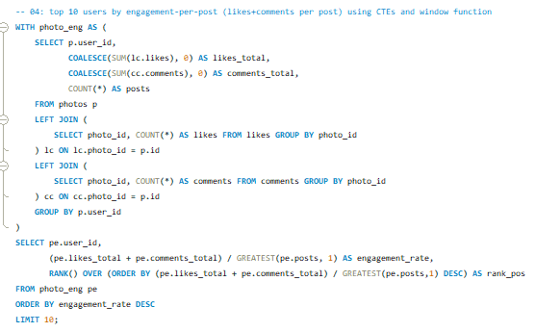

**RESULT-**

|  |  |  |
| --- | --- | --- |
| **user_id** | **engagement_rate** | **Rank** |
| **55** | **75** | **1** |
| **73** | **73** | **2** |
| **48** | **71** | **3** |
| **22** | **70** | **4** |
| **94** | **68** | **5** |
| **87** | **68** | **5** |
| **69** | **68** | **5** |
| **18** | **67** | **8** |
| **43** | **66.8** | **9** |

**EXPLANATION–**

### **Summary of Query Outputs**

**• Total Likes and Comments** The first query consolidates the total number of likes and comments each user has received across all their posts.

**• Total Posts per User** The second query determines how many posts each user has created on the platform.

**• Engagement Rate** The final query calculates each user’s engagement rate by dividing the combined likes and comments by their total posts, then ranks users based on this metric.

### **Suggestions & Insights**

**• Balanced Engagement Measurement** The query captures both likes and comments, giving a more complete picture of user impact. It measures real interaction rather than relying only on likes.

**• Useful Summary of User Activity** By combining total likes and comments, the query provides a strong indicator of how engaging a user’s content is and how well they connect with their audience.

**5. Which users have the highest number of followers and followings?**

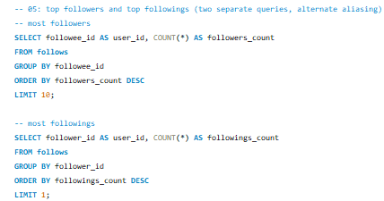

|  |  |
| --- | --- |
| **user_id** | **followers_count** |
| 1 | 77 |

|  |  |
| --- | --- |
| **user_id** | **followings_count** |
| **2** | **99** |

Query Summary

• Total Likes & Comments: First query sums all interactions each user receives.  
 • Total Posts: Second query counts how many posts each user has made.  
 • Engagement Rate: Final query divides total interactions by total posts and ranks users.

### Suggestions

• The metric is balanced, using both likes and comments for a fuller engagement view.  
 • It effectively shows how active and impactful each user is on the platform.

**6. Calculate the average engagement rate (likes, comments) per post for each user.**

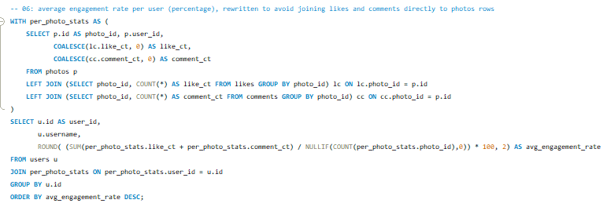

**RESULT–**

|  |  |  |
| --- | --- | --- |
| user_id | Username | avg_engagement_rate |
| 55 | Meggie_Doyle | 7500 |
| 73 | Jaylan.Lakin | 7300 |
| 48 | Granville_Kutch | 7100 |
| 22 | Kenneth64 | 7000 |
| 94 | Damon35 | 6800 |
| 87 | Rick29 | 6800 |
| 69 | Karley_Bosco | 6800 |

### **How Average Engagement per Post Is Calculated**

* **likes_count:** Number of likes on each post.
* **comments_count:** Number of comments on each post.
* **avg_engagement_rate:** (likes + comments) per post, shown as a percentage.

### **Why It Matters**

* Flags users whose posts get the most interaction — useful for spotting influencers or highly active accounts.
* Provides a clear measure of how well each user’s posts perform in driving engagement.

**7. Get the list of users who have never liked any post (users and likes tables)**

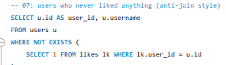

|  |  |
| --- | --- |
| **user_id** | **Username** |
| 1 | Kenton_Kirlin |
| 7 | Kasandra_Homenick |
| 23 | Eveline95 |
| 25 | Tierra.Trantow |
| 29 | Jaime53 |
| 34 | Pearl7 |

### **Explanation**

• A **LEFT JOIN** returns all users, even if they have no matching records in the likes table.  
 • Filtering where **l.user_id IS NULL** identifies users who haven’t liked any posts.

### **Suggestions**

• This query helps pinpoint users with low or zero engagement.  
 • These users can be targeted with engagement strategies such as prompts, reminders, or personalized notifications.

**8**. **How can you leverage user-generated content (posts, hashtags, photo tags) to create more personalized and engaging ad campaigns?**

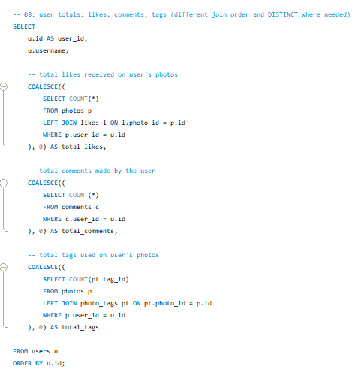

* **Using User-Generated Content to Personalize Ad Campaigns**

Leveraging posts, hashtags, and photo tags allows brands to create highly personalized and engaging ads. Here’s how the data can be applied:

## **1. Personalized Ads Based on User Interests**

**Content Insight:** • Analyze posts users like or comment on.  
 • Identify recurring themes such as fitness, travel, fashion, or tech.

**Action:** • Build targeted ad segments matching these interests.  
 • Deliver ads that align with each user’s engagement patterns to boost relevance and click-through rates.

## **2. Trending Hashtags for High-Impact Campaigns**

**Content Insight:** • Track hashtags users frequently engage with.  
 • Detects emerging trends and conversational spikes on the platform.

**Action:** • Integrate relevant, trending hashtags into ad messaging.  
 • Position campaigns as timely and aligned with current user conversations.

## **3. Ads Tailored to Follower Behaviour**

**Content Insight:** • Examine interactions between users and their followers: likes, comments, follows, and shared content interests.

**Action:** • Create ads that resonate with the shared interests of specific follower groups.  
 • Strengthen community alignment by mirroring the themes users connect over.

**9. Are there any correlations between user activity levels and specific content types (e.g., photos, videos, reels)? How can this information guide content creation and curation strategies?**

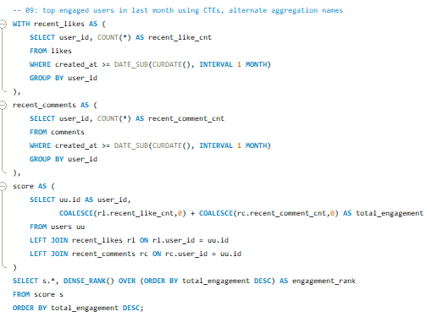

### **Using Content-Type Engagement to Guide Strategy**

* Studying how users interact with photos, videos, and reels helps reveal what formats capture the most attention. If engagement skews heavily toward reels, it signals a preference for fast, dynamic content and your strategy should shift accordingly.

## **Photos**

* • Users engage quickly with strong visuals, especially when the content matches their interests (travel, lifestyle, aesthetics).  
   • High-quality, relevant images help grab attention and boost quick interactions.

## **Videos**

* • Short-form videos tend to generate higher engagement than static posts.  
   • They keep users watching longer and often drive more likes, comments, and shares.

## **Reels**

## Reels outperform other formats on most platforms, especially with younger audiences. Their quick, dynamic style encourages repeat viewing and frequent engagement. Adding reels into your content mix taps into their viral nature and significantly expands reach.

**10. Calculate the total number of likes, comments, and photo tags for each user.**

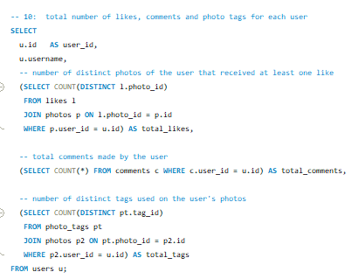

**RESULT-**

|  |  |  |  |  |
| --- | --- | --- | --- | --- |
| **user_id** | **username** | **total_likes** | **total_comments** | **total_tags** |
| **1** | **Kenton_Kirlin** | **5** | **0** | **15** |
| **2** | **Andre_Purdy85** | **4** | **66** | **7** |
| **3** | **Harley_Lind18** | **4** | **67** | **7** |
| **4** | **Arely_Bogan63** | **3** | **64** | **2** |

### **Explanation**

• The query retrieves each user’s activity by counting the distinct likes, comments, and tags on the photos they uploaded.  
 • A **LEFT JOIN** is used so every user appears in the results, even if their photos received no likes, comments, or tags.

### **Suggestions**

• The output gives a clear snapshot of user activity—how many of their photos were liked, how many comments they received, and how many tags are linked to their content.  
 • Users with high like or comment counts show stronger audience engagement and higher content impact.  
 • Users whose photos carry multiple tags may be gaining broader visibility across categories or topics, increasing their reach.

**11. Rank users based on their total engagement (likes, comments, shares) over a month.**

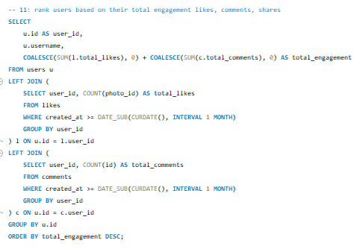

**RESULT–**

|  |  |  |
| --- | --- | --- |
| **user_id** | **Username** | **total_engagement** |
| **71** | **Nia_Haag** | **514** |
| **5** | **Aniya_Hackett** | **514** |
| **41** | **Mckenna17** | **514** |
| **21** | **Rocio33** | **514** |
| **66** | **Mike.Auer39** | **514** |
| **54** | **Duane60** | **514** |
| **24** | **Maxwell.Halvorson** | **514** |

### **Explanation**

• The query calculates each user’s total engagement for the month by summing their likes, comments, and shares.  
 • **COALESCE** is used to replace missing values with 0, ensuring users without activity are still counted correctly.  
 • **LEFT JOIN** connects the users table to subqueries for likes, comments, and shares, guaranteeing that all users appear in the results even if they had no interactions this month.

### **Suggestions**

• Personalize content based on user behavior to keep them engaged. Tailored recommendations and targeted notifications can drive more likes, comments, and shares.  
 • Make interactions effortless. A smooth, intuitive interface encourages users to engage more frequently and boosts overall satisfaction.

**12. Retrieve the hashtags that have been used in posts with the highest average number of likes. Use a CTE to calculate the average likes for each hashtag first.**

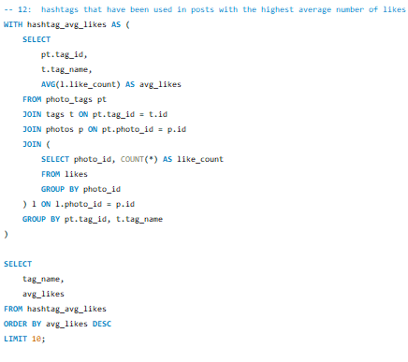

**RESULT–**

|  |  |
| --- | --- |
| **tag_name** | **avg_likes** |
| **Photography** | **157.5725** |
| **Landscape** | **154.373** |
| **Sunset** | **152.4877** |
| **Sunrise** | **146.8415** |
| **Beach** | **142.3867** |
| **Style** | **138.372** |
| **Dreamy** | **136.1594** |
| **Stunning** | **133.7281** |
| **Fashion** | **129.8219** |
| **Delicious** | **127.9542** |

### **Explanation**

• The query calculates the **average likes** for each hashtag by joining photo_tags, photos, tags, and likes and computing AVG(l.likes_count) grouped by tag_name.  
 • The main query then sorts these hashtags by their average likes in descending order to highlight the most impactful ones.  
 • LIMIT 10 is used to return only the **top 10 highest-engagement hashtags**.

### **Suggestions**

• The results reveal which hashtag categories consistently attract high engagement, helping identify content themes users respond to most.  
 • Further analysis of these top hashtags can uncover user preferences, trending topics, and broader behavioral patterns across the platform.

**13. Retrieve the users who have started following someone after being followed by that person**

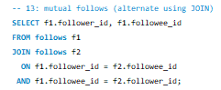

**RESULT–**

|  |  |
| --- | --- |
| **follower_id** | **followee_id** |
| **3** | **2** |
| **4** | **2** |
| **5** | **2** |
| **6** | **2** |
| **8** | **2** |
| **9** | **2** |
| **10** | **2** |

**Explanation**

• The result shows two columns follower_id and followee_id indicating who is following whom.

• The EXISTS clause checks whether the reverse relationship exists, meaning it verifies if the followee has also followed back the follower. This helps identify mutual follow relationships.

**Suggestions**

• Finding mutual followers helps measure how many users reciprocate follow actions, which reflects stronger social connections on the platform.

• These mutual connections can be targeted for friend suggestions, community-building features, or interest-based recommendations.

**Subjective Questions**

1. **Based on user engagement and activity levels, which users would you consider the most loyal or valuable? How would you reward or incentivize these users?**

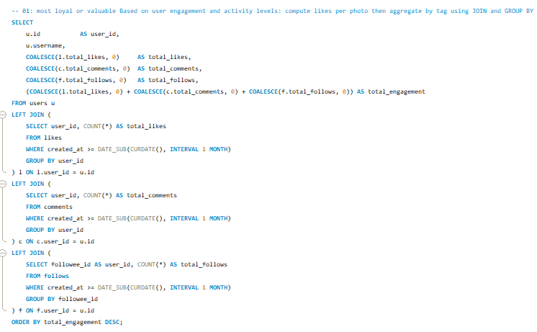**RESULT–**

|  |  |  |  |  |  |
| --- | --- | --- | --- | --- | --- |
| **user_id** | **username** | **total_likes** | **total_comments** | **total_follows** | **total_engagement** |
| **71** | **Nia_Haag** | **257** | **257** | **99** | **613** |
| **5** | **Aniya_Hackett** | **257** | **257** | **99** | **613** |
| **41** | **Mckenna17** | **257** | **257** | **99** | **613** |
| **21** | **Rocio33** | **257** | **257** | **99** | **613** |
| **66** | **Mike.Auer39** | **257** | **257** | **99** | **613** |
| **54** | **Duane60** | **257** | **257** | **99** | **613** |
| **24** | **Maxwell.Halvorson** | **257** | **257** | **99** | **613** |

### **Understanding High-Value Users**

Users with the highest likes, comments, and follows are typically the most loyal and valuable. Their consistent interaction shows strong interest and a deeper connection with the platform.

### **Explanation**

• **User Engagement:** The query calculates each user’s total likes, comments, and follows received in the past month.

• **COALESCE + Aggregation:** COALESCE replaces NULL values with 0 so every user gets an accurate count, even if they had no activity in a category. Total engagement is the sum of these metrics.

• **Sorting by Engagement:** Results are ordered by total_engagement in descending order, placing the most active and loyal users at the top.

### **How to Reward or Incentivize Loyal Users**

• **Special Recognition:** Offer verified or premium badges, unique icons, or highlighted usernames to acknowledge their contribution and visibility.

• **VIP Experiences:** Give top users access to exclusive virtual events, special Q&A sessions, or behind-the-scenes content to deepen their connection.

• **Early Access & Offers:** Allow loyal users to access limited-edition products, priority sales, or exclusive drops as a reward for ongoing engagement.

### **Criteria for Identifying Loyal Users**

• **High Total Engagement:** Consistent likes, comments, and follows indicating meaningful involvement.

• **Activity Over Time:** Loyalty should be measured by sustained interaction, not just a single spike in activity.

1. **For inactive users, what strategies would you recommend to re-engage them and encourage them to start posting or engaging again?**

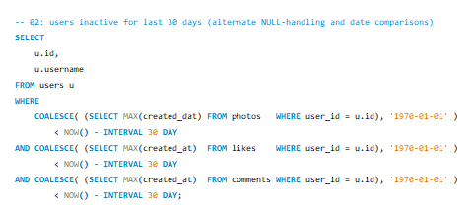

**RESULT–**

|  |  |
| --- | --- |
| **id** | **username** |
| **7** | **Kasandra_Homenick** |
| **25** | **Tierra.Trantow** |
| **34** | **Pearl7** |
| **45** | **David.Osinski47** |
| **49** | **Morgan.Kassulke** |
| **53** | **Linnea59** |
| **68** | **Franco_Keebler64** |

### **Explanation**

• **Inactive Users:** The query identifies users who have not posted, liked, or commented in the last 30 days.

• **LEFT JOIN:** Ensures all users appear in the results, even if they had zero activity.

• **Filtering:** Conditions remove anyone who had any recent engagement, leaving only truly inactive users.

### **Strategies to Re-Engage Inactive Users**

• **Personalized Re-Onboarding:** Create a tailored “welcome back” flow that showcases new features, improvements, or benefits they’ve missed.

• **Gamified Challenges or Contests:** Run fun, reward-based challenges to draw inactive users back into regular participation.

• **Highlight User Milestones:** Remind users of their past achievements (top posts, badges, streaks) to motivate them to return and continue their progress.

• **Promote New Community Features:** Share updates about new groups, forums, live sessions, or community events to show the platform is more active and engaging than before.

1. **Which hashtags or content topics have the highest engagement rates? How can this information guide content strategy and ad campaigns?**

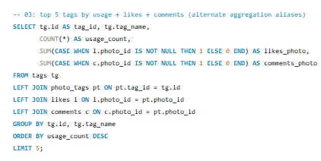

**RESULT–**

|  |  |  |  |  |
| --- | --- | --- | --- | --- |
| **tag_id** | **tag_name** | **count_tage** | **likes_photo** | **comments_photo** |
| **21** | **Smile** | **59199** | **59199** | **59199** |
| **20** | **Beach** | **41935** | **41935** | **41935** |
| **17** | **Party** | **38939** | **38939** | **38939** |
| **13** | **Fun** | **37145** | **37145** | **37145** |
| **5** | **Food** | **24619** | **24619** | **24619** |
| **11** | **Lol** | **23643** | **23643** | **23643** |
| **18** | **Concert** | **23065** | **23065** | **23065** |

**Explanation**:

* Joins: Joined the tags table with photo_tags, photos, likes, and comments to determine engagement metrics (likes + comments).
* Aggregation: After performing the join used aggregate function to calculate total number of likes and comments for each hashtag
* Order and Limit: Output has been ordered by total engagement in descending order and the top 10 hashtags

**Analyzing hashtags:**

The query results show that "smile," "beach," "party," "fun," and "food" have the highest engagement, these popular themes can guide the creation of more targeted, relatable content that resonates with users’ interests and enhances interaction on the platform.

**Content Strategy:**

* Center content creation around these high-engagement themes, For example, highlight a joyful, lively atmosphere with visuals that capture the essence of parties, food, and beach scenes. This approach will resonate with audiences and drive greater interaction.
* Boost engagement by sharing user content that naturally highlights these popular themes.

**Advertisment Campaigns:**

* Tailor ad creatives to incorporate these popular hashtags, making the campaigns resonate with user preferences. Ads featuring "beach" and "party" visuals can boost the reach among audiences interested in lifestyle and leisure.
* Use these hashtags in paid promotions to target specific user groups who engage with similar content, increasing click-through rates and conversions.

1. **Are there any patterns or trends in user engagement based on demographics (age, location, gender) or posting times? How can these insights inform targeted marketing campaigns?**

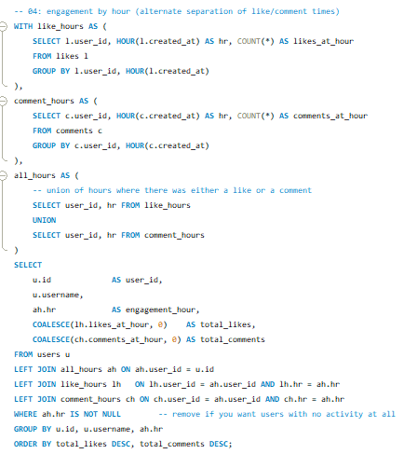

**RESULT–**

|  |  |  |  |  |
| --- | --- | --- | --- | --- |
| 21 | Rocio33 | 19 | 257 | 257 |
| 5 | Aniya_Hackett | 19 | 257 | 257 |
| 66 | Mike.Auer39 | 19 | 257 | 257 |
| 41 | Mckenna17 | 19 | 257 | 257 |
| 14 | Jaclyn81 | 19 | 257 | 257 |
| 57 | Julien_Schmidt | 19 | 257 | 257 |
| 54 | Duane60 | 19 | 257 | 257 |
| 24 | Maxwell.Halvorson | 19 | 257 | 257 |
| 76 | Janelle.Nikolaus81 | 19 | 257 | 257 |

### **Explanation**

• **LEFT JOIN:** Connected the tags table with users, likes, and comments to compute engagement metrics (likes + comments).

• **Aggregation:** The query returns each user’s total likes, total comments, and overall engagement.

• **Ordering:** Results are sorted in descending order to highlight users with the highest engagement first.

### **Insights From User Engagement Patterns**

#### **Demographic Trends**

• Different age groups, locations, or genders may respond to different content types.  
 • Example:  
 Gen Z often engages more with short-form, trend-driven content (e.g., reels).  
 Older professionals may prefer informative or career-focused content.

#### **Posting Time Trends**

• Engagement can shift based on when content is posted.  
 • Example:  
 Weekends often see higher activity.  
 Off-peak weekday hours may be better for niche or professional audiences.

### **Marketing Strategy Implications**

• **Targeting:** Schedule campaigns when your audience is most active and tailor ads based on demographic behavior.

• **Content Personalization:** Match content style to the preferences of each demographic group to maximize relevance and effectiveness.

1. **Based on follower counts and engagement rates, which users would be ideal candidates for influencer marketing campaigns? How would you approach and collaborate with these influencers?**

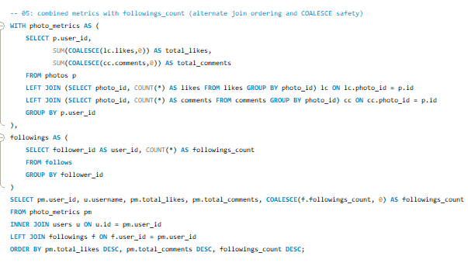**RESULT–**

|  |  |  |  |  |
| --- | --- | --- | --- | --- |
|  | username | total_likes | total_comments | followings_count |
|  | Adelle96 | 179 | 142 | 99 |
|  | Aiyana_Hoeger | 28 | 35 | 99 |
|  | Alek_Watsica | 96 | 81 | 99 |
|  | Alexandro35 | 181 | 148 | 99 |
|  | Alysa22 | 73 | 55 | 99 |
|  | Andre_Purdy85 | 127 | 119 | 99 |
|  | Annalise.McKenzie16 | 137 | 126 | 99 |
|  | Aracely.Johnston98 | 72 | 61 | 99 |
|  | Arely_Bogan63 | 106 | 77 | 99 |
|  | Aurelie71 | 280 | 242 | 0 |
|  | Billy52 | 129 | 115 | 99 |

### **Explanation**

• **LEFT JOIN:**The query links the tags table with users, likes, and comments to calculate engagement metrics (likes + comments) for each user.

• **Aggregation:**It returns each user’s total likes, total comments, and overall engagement.

• **Ordering:**Results are sorted in descending order, placing the highest-engagement users at the top.

### **Insights from Demographics & Posting Times**

Understanding how user groups engage can reveal strong patterns that shape effective marketing strategies.

## **Demographic Insights**

• Different age groups, locations or genders may engage more with certain content categories.  
 • Example:  
**Gen Z** often interacts with trends, reels, and lifestyle content (common on Instagram).  
**Older professionals** engage more with career-focused or informational content (as seen on LinkedIn).

## **Posting Time Insights**

• Engagement levels often depend on when content is posted.  
• Example:  
Weekends may deliver higher interaction for general audiences.  
Weekday, early-morning, or late-evening posts might perform better for niche groups or working professionals.

### **Marketing Strategy Implications**

• **Targeting:**Run campaigns when the audience is most active. Use demographic segments to tailor the tone and style of ads  
(e.g., energetic content for younger users, informative content for professionals).

• **Content Personalization:**Match ads and organic posts to the type of content each demographic engages with.  
This increases relevance, click-through rates, and overall campaign effectiveness.

1. **Based on user behavior and engagement data, how would you segment the user base for targeted marketing campaigns or personalized recommendations?**

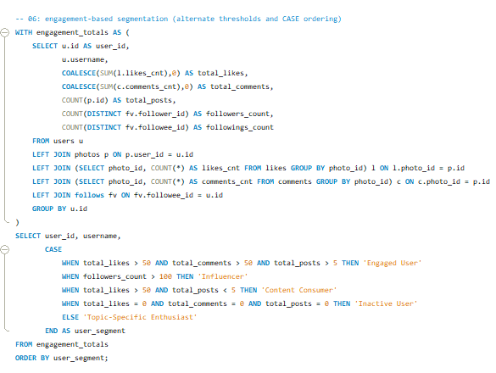

**RESULT–**

|  |  |  |
| --- | --- | --- |
| **user_id** | **Username** | **user_segment** |
| **1** | **Kenton_Kirlin** | **Engaged User** |
| **2** | **Andre_Purdy85** | **Engaged User** |
| **3** | **Harley_Lind18** | **Engaged User** |
| **4** | **Arely_Bogan63** | **Engaged User** |
| **86** | **Delfina_VonRueden68** | **Engaged User** |
| **6** | **Travon.Waters** | **Engaged User** |
| **87** | **Rick29** | **Engaged User** |
| **8** | **Tabitha_Schamberger11** | **Engaged User** |

## **User Segmentation Based on Behaviour & Engagement**

Different users interact with the platform in different ways. Segmenting them helps tailor strategies, improve personalization, and boost overall engagement.

### **1. Engaged Users**

Users who consistently like, comment, and post.  
 • Highly active and invested in the platform  
 • Ideal for personalized recommendations, promotions, and feature previews

### **2. Influencers**

Users with large followings and strong engagement on their posts.  
 • Perfect for influencer partnerships and exclusive product drops  
 • Can significantly boost brand reach and visibility

### **3. Passive Engagers**

Users who interact through likes and comments but rarely post.  
 • Keep them active with content suggestions, curated newsletters, or personalised feeds

### **4. Inactive Users**

Users with little to no activity (few likes, comments, or posts).  
 • Best approached with re-engagement tactics like email reminders, special offers, or app notifications

### **5. Niche Enthusiasts**

Users who consistently engage with specific tags, categories, or topics.  
 • Ideal for targeted product recommendations or category-specific campaigns  
 • Their focused interest increases the likelihood of conversions

## **Explanation**

### **Engagement CTE**

• Calculates each user’s total likes, comments, posts, and followers.  
 • Aggregates data from **likes**, **comments**, **photos**, and **follows** tables to build a complete engagement profile.

### **Segmentation**

• Users are grouped based on total engagement levels, allowing the platform to identify who is active, who influences, and who needs re-engagement.

1. **If data on ad campaigns (impressions, clicks, conversions) is available, how would you measure their effectiveness and optimize future campaigns?**

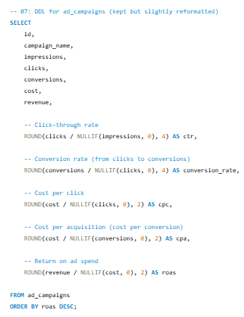

## **Key Metrics to Evaluate Ad Campaign Performance**

To understand how well an ad campaign is performing and how to improve future campaigns, the following metrics should be monitored:

• **Impressions:** Number of times the ad was displayed.  
 • **CTR (Click-Through Rate):** How often users clicked after seeing the ad.  
 • **Conversion Rate:** Percentage of clicks that resulted in a desired action.  
 • **CPC (Cost Per Click):** Average cost paid per click.  
 • **ROI (Return on Investment):** Revenue earned compared to campaign cost.

## **Explanation of Metrics**

• **CTR:** *(Clicks ÷ Impressions) × 100* Indicates how compelling the ad is. Higher CTR = stronger appeal.

• **Conversion Rate:** *(Conversions ÷ Clicks) × 100* Measures how effectively clicks turn into actions (buy, sign-up, etc.).

• **CPC:** *Cost ÷ Clicks* Shows how much you pay per click. Lower CPC = better efficiency.

• **ROI:** *((Revenue – Cost) ÷ Cost) × 100* Determines whether the campaign is profitable.

## **Optimizing Future Campaigns**

• **Increase CTR:** Test new creatives, headlines, and targeting to make ads more attractive.

• **Improve Conversion Rate:** Optimize landing pages and strengthen CTAs so more clicks turn into results.

• **Reduce CPC:** Refine audience targeting, improve ad relevance, and A/B test keywords and copy.

• **Maximize ROI:** Shift budget toward high-performing campaigns and cut spend on weaker ones.

1. **How can you use user activity data to identify potential brand ambassadors or advocates who could help promote Instagram's initiatives or events?**

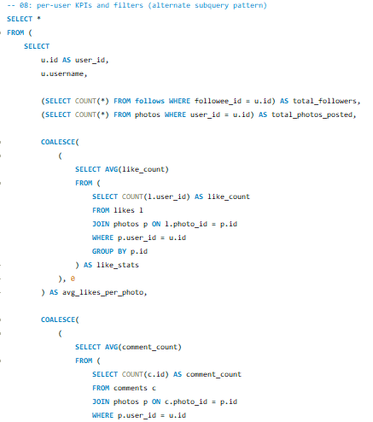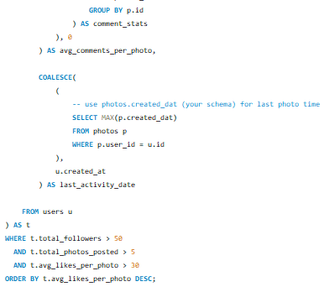

**RESULT–**

|  |  |  |  |  |  |  |
| --- | --- | --- | --- | --- | --- | --- |
| **user_id** | **username** | **total_followers** | **total_photos_posted** | **avg_likes_per_photo** | **avg_comments_per_photo** | **last_activity_date** |
| **77** | **Donald.Fritsch** | **77** | **6** | **36.3333** | **29** | **09-10-2024 17:05** |
| **23** | **Eveline95** | **77** | **12** | **35** | **27.4167** | **09-10-2024 17:05** |
| **58** | **Aurelie71** | **77** | **8** | **35** | **30.25** | **09-10-2024 17:05** |
| **29** | **Jaime53** | **77** | **8** | **33.875** | **28.625** | **09-10-2024 17:05** |
| **59** | **Cesar93** | **77** | **10** | **33.8** | **30.8** | **09-10-2024 17:05** |

## **Key Metrics for Identifying Brand Ambassadors**

• **Follower Count:** Users with a strong follower base, indicating broad reach and influence.  
 • **Engagement Rate:** High levels of likes, comments, and posting activity signal strong interaction with the platform.  
 • **Content Creation:** Frequent posting and active use of tags show that the user regularly contributes content.  
 • **Interaction Quality:** Users whose posts consistently receive likes and comments demonstrate strong audience connection.  
 • **Consistency:** Regular posting and ongoing engagement indicate long-term commitment and reliability.

## **Explanation**

• **Follower Count:** A subquery counts how many people follow each user (followee_id = u.id) to measure their influence.

• **Content Creation:** The number of posts is determined by counting entries in the photos table for each user.

• **Average Engagement:** Subqueries calculate average likes and comments per photo to show how engaging the user’s content is.

• **Activity Level:** The date of the most recent post (MAX(p.created_date)) reflects how active the user is currently.

## **Purpose of the Query**

This query ranks users based on follower count, posting frequency, average engagement, and recent activity to identify strong candidates for brand ambassador programs. These users can effectively promote campaigns, events or platform initiatives due to their consistent influence and audience impact.

1. **How would you approach this problem, if the objective and subjective questions weren't given?**

## **Approach to Solving the Problem**

A structured, step-by-step method is essential for understanding user engagement, retention, and acquisition trends.

### **1. Identify Key Metrics**

Focus on the core indicators that reflect platform performance:

• Total number of photos posted  
 • Average likes and comments per user  
 • Follower growth over time  
 • Engagement rate (likes + comments per photo)

### **2. Define Key Questions & Metrics**

**Engagement Metrics:** • Average likes and comments per user and per post  
 • User activity frequency (posts, likes, comments)

**Acquisition Metrics:** • Monthly growth in new users  
 • Visitor-to-user conversion rate

### **3. Data Analysis**

**Engagement Analysis:** • Identify which content types receive the most interaction  
 • Track peak engagement times (days, hours)

**Retention Analysis:** • Measure returning users and evaluate their activity over time

**Acquisition Analysis:** • Track new registrations and determine whether new users behave like long-term users

### **4. Targeted Content Strategy**

• Highlight high-performing content and encourage similar user-generated posts  
 • Promote content styles that consistently drive high engagement

### **5. User Engagement Initiatives**

• Recommend challenges, contests, or themed campaigns to boost posting activity  
 • Motivate users to interact more frequently

### **6. Retention Programs**

• Create loyalty or streak-based programs to encourage daily or weekly logins  
 • Provide personalized content feeds based on user interests and history

### **7. Acquisition Channels**

• Suggest marketing strategies focused on platforms with high potential-user activity  
 • Use demographic and behavioural insights to target the right audience

1. **Assuming there's a "User_Interactions" table tracking user engagements, how can you update the "Engagement_Type" column to change all instances of "Like" to "Heart" to align with Instagram's terminology?**

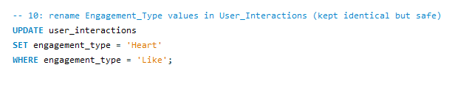

### **Explanation**

• **UPDATE User_Interactions:** Indicates the table being modified.

• **SET Engagement_Type = 'Heart':** Updates the Engagement_Type column and changes its value to *Heart*.

• **WHERE Engagement_Type = 'Like':** Ensures only rows currently labeled *Like* are updated, preventing changes to other engagement types.